Which HVAC Products Outsmart the Rest?

Members of The NEWS’ advisory board discuss their go-to products

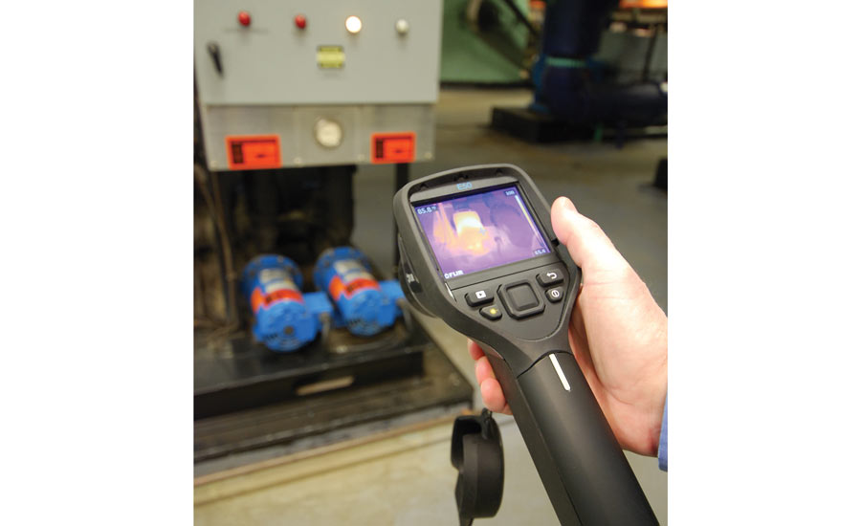

FLIR THERMAL IMAGING CAMERA: “The FLIR helps our techs get to the bottom of persistent, long-standing problems,” said Kyle.With so many [intelligent products](https://www.achrnews.com/keywords/3928-smart-devices) on the market, how do contractors know which ones are really smart and which ones are just passing, so to speak? There are a lot of variables that make it impossible to say there’s one product that’s better than all the rest in every situation; however, everyone has their favorite. The NEWS wanted to know exactly what those favorites were, and here’s what the advisory board members had to say.



David Kyle  
President, Trademasters Service Corp., Lorton, VA



Rich Morgan  
CEO, MagicTouch Mechanical Inc., Mesa, Arizona

*The NEWS:* If you had to recommend just one intelligent product for all HVAC contractors to offer/use, what would it be and why?

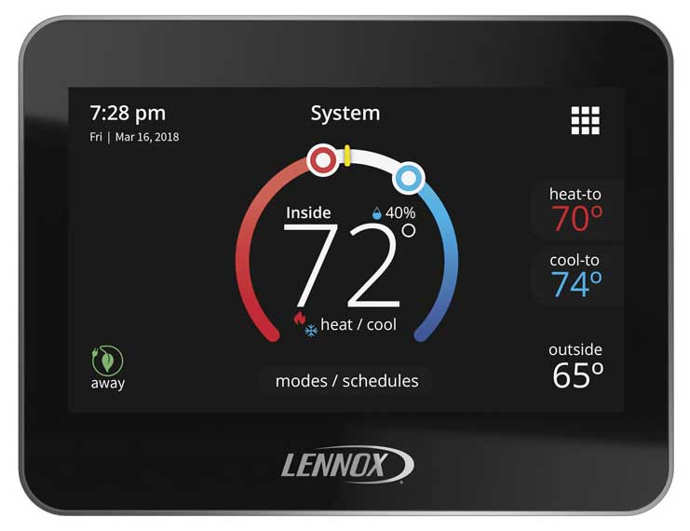ICOMFORT S30: “It’s not too often in our industry that we can say a product is sexy, but I think it’s fair to say that describes the S30,” said Morgan.

Rich Morgan, CEO, MagicTouch Mechanical Inc., Mesa, Arizona: With the seemingly non-stop influx of IoT and intelligent products flooding the HVAC market in recent years, it’s hard to pick just one. If I was forced to pick just one, my favorite intelligent product on the market today is the Lennox iComfort S30 thermostat (and its counterpart the E30). It’s not too often in our industry that we can say a product is sexy, but I think it’s fair to say that describes the S30 … and our clients seem to agree.

David Kyle, president, Trademasters Service Corp., Lorton, Virginia: There are so many great products available now that have become valuable to the business, and everyone has their favorite products, but I’ve seen some great results with one. So, if I had to recommend just one intelligent product, it would be the FLIR thermal imaging camera. We have them in most of our service trucks now and at the buildings we operate and maintain. We started with one and passed it around among our technicians, and each tech seemed to find a new use for it.

*The NEWS:* Can you please provide a few examples of situations where your employees have used this product to solve comfort and/or efficiency issues?

Morgan: Just a few weeks ago, we replaced two split gas systems with top-of-the-line Lennox XC25 variable-speed inverter systems specifically because the client wanted the iComfort S30 thermostats. His main interest was the ability to better monitor and control humidity in his home, but he really liked all the additional features the S30 has to offer. What was most interesting about this project was that we replaced two working dual-stage systems that were working great … we installed them in 2010, and they had plenty of life left in them. The units we removed were donated to a local charity, and the customer (in his own words) said his new system and controls are “even better than he expected,” a win-win.

As an HVAC contractor for over two decades, I can count on one finger the times a client replaced two very efficient, working a/c units, coils, and furnaces because he wanted a specific thermostat.

Kyle: Sometimes, when some buildings are populated slowly, issues related to the initial constructions or a renovation can go months or years without being discovered. At a recently renovated building we had just started maintaining, our team used a FLIR to help diagnose a problem with a section of the building that was not getting any cooling. Our technicians used the FLIR to see what sections of the piping risers (that were not visible or accessible) were cold enough to have chilled water. Ultimately, they were able to narrow down the location of the blockage, saving both time and many access holes in walls and ceilings. It turned out that a valve concealed in the wall was closed. It was behind really expensive wood paneling. We bypassed the valve by installing a new section of pipe riser and got cooling to this area.

Techs are routinely identifying duct issues like leakage or loose insulation in difficult-to-access and inaccessible areas and have even found a duct that had come apart behind a wall. [They] take images of supply registers, and they immediately have an idea of what may be going on. When there are performance issues, the FLIR is a great diagnostic tool.

*The NEWS:* What type of feedback have you received from the customers concerning this product?

Morgan: I’m yet to find one client who doesn’t give the S30 high marks. They all love it. Hence the reason it’s my favorite new intelligent product on the market right now.

Kyle: We’ve had new clients who were happy that we were able to find the root of their comfort issues without cutting through ceilings and walls to investigate.

*The NEWS:* What trends have you seen with this product (or similar products), and how do you see that evolving?

Morgan: The S30 and products like it give us the ability to better connect with our clients and, by default, increase customer loyalty. Not only are they happy with their purchase and, therefore, us for introducing and installing it for them, but we can offer complete system monitoring. The S30 works with Lennox communicating systems only (the E30 works with other brands), and allows us to see and respond to system alerts. It’s hard not to love a product that “bonds” us with our customer.

Kyle: A trend we have noticed is that the price of imaging technology like the FLIR has been coming down, and the image quality has been going up, just like it did for digital cameras. The quality of the images on screen are good enough to snap a picture on your phone, and in most cases, we don’t have to bother with memory cards to record them.

Our techs can show homeowners even if they aren’t there, since they can instantly transmit those images in a text or email message on their phones.

The FLIR helps our techs get to the bottom of persistent, long-standing problems that, without it, would have required much more destructive means to see. Sometimes problems have been around so long, the client has decided they’d have to live with it — like a water pressure problem or a hot bedroom with duct disconnected behind a wall.

While they don’t replace training and expertise, smart tools can help great techs work more efficiently and provide our clients clear information to make decisions.

I mean, who doesn’t want the power to look through walls, right?

Publication date: 11/26/2018

from：https://www.achrnews.com/articles/140158-which-hvac-products-outsmart-the-rest